Question 1:

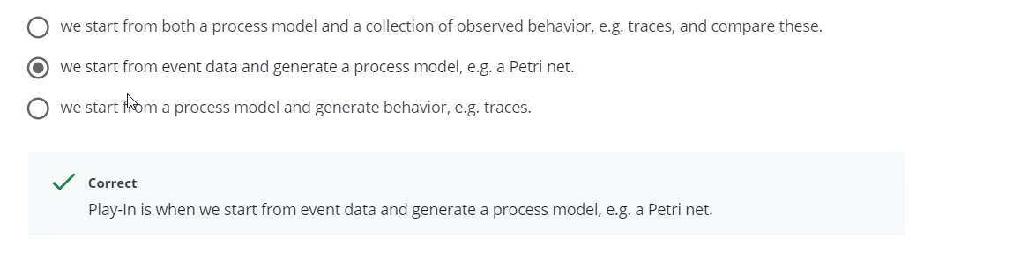

Play-Out is when we start from a process model and generate behavior, e.g. traces.

Play-In is when we start from event data and generate a process model, e.g. a Petri net.

Replay is when we start from both a process model and a collection of observed behavior, e.g. traces, and compare these by replaying the traces on the process model.

Question 2:

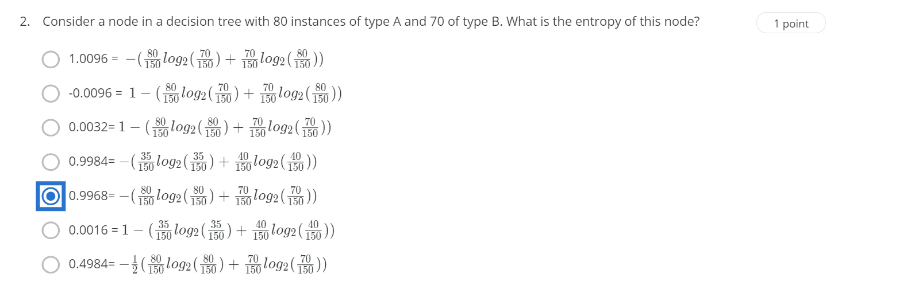

E = - (80/150 log(80/150) + 70/150 log(70/150)) = -(-0.483-0.512) = 0.995

Question 3 :

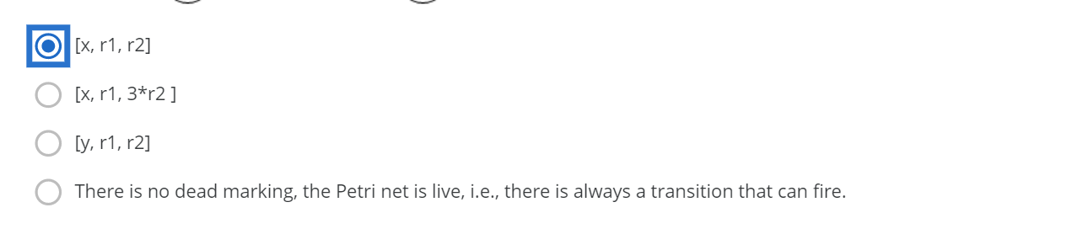

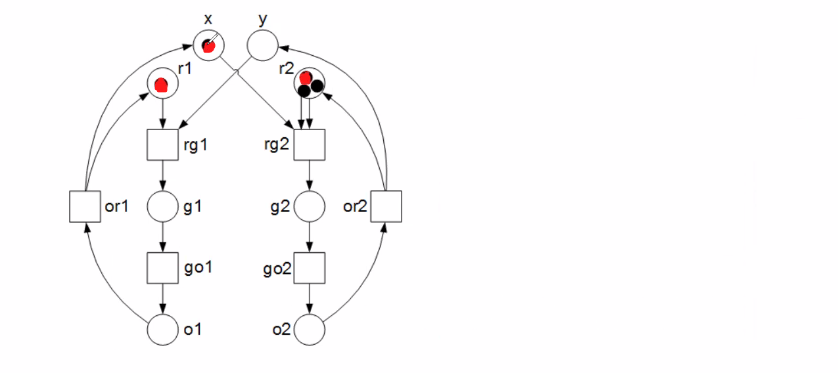

Question 4

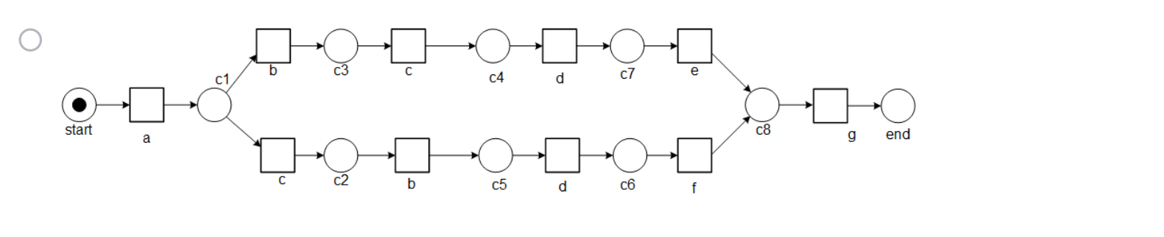

This option is rejected because “cbde” is not satisfying. Each transition should have a unique name but in this case it is not so.



This option is rejected because only one trace is possible and the other two are not possible

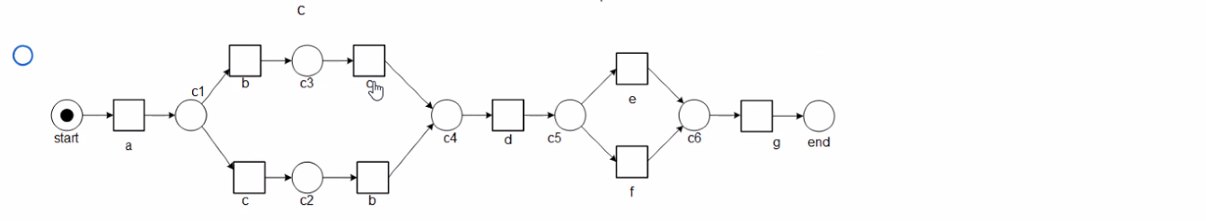

Even Though all the three cases are satisfied. This takes a longer path when compared with the correct answer

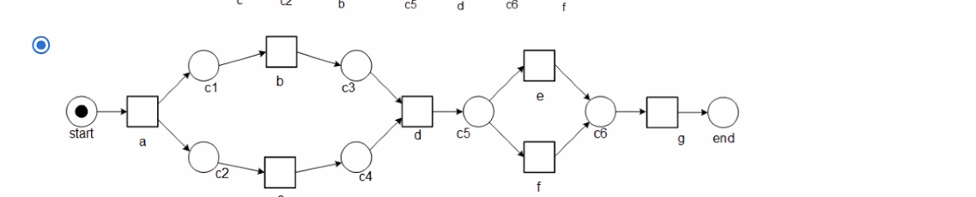

This is the correct answer because it satisfies all the 3 cases and it is precise

Question 5

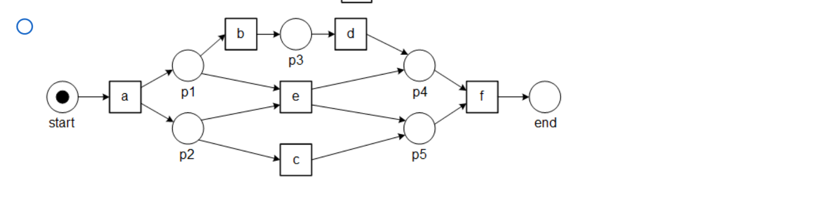

This is rejected because it doesn't satisfy <acdbf>

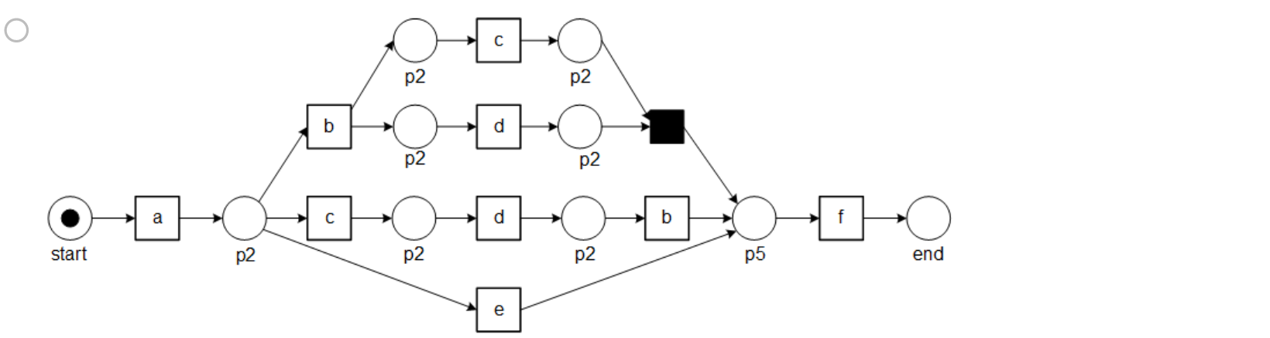

This is rejected because it doesn’t satisfy <adbcf>

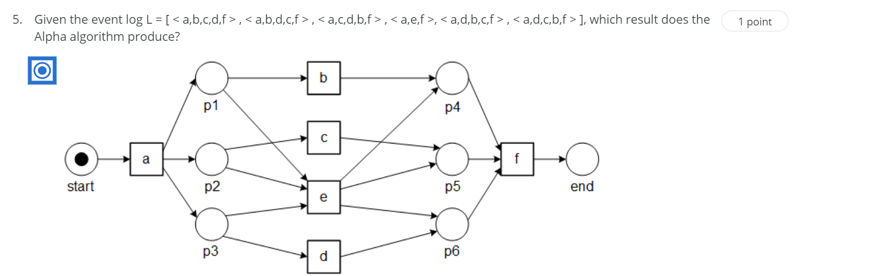

This is the right option

Question 6:

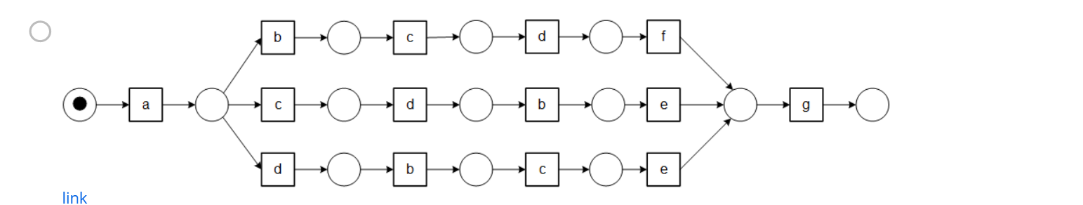

<abcdeg> is not possible

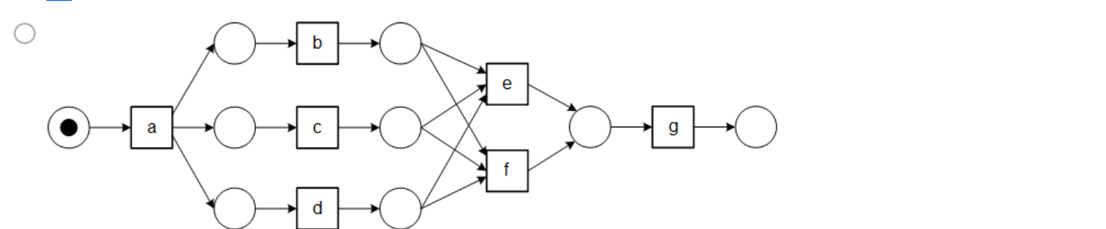

This option is rejected because it also has other possibilities which is not required

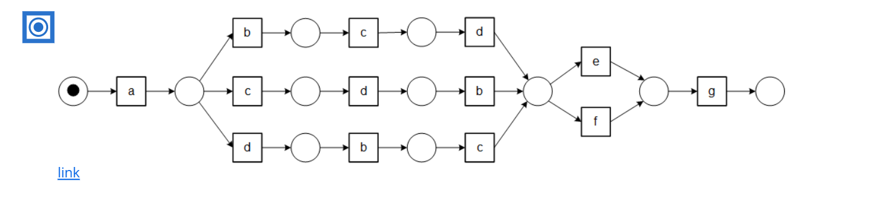

This is the correct option, This option fits all the cases and has no extra cases.

Question 7

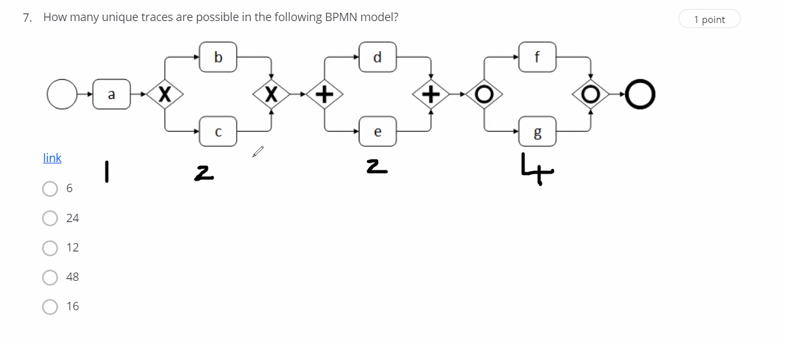

For a = 1

For x it is either b or c. so 2 possibilities

For + it is de and ed. So 2 possibilities

For o it is f,g,fg,gf. So 4 possibilites

16 is the answer 1\*2\*2\*4

Question 8 :

[< a,b,c,d,f,g > , < a,b,d,c,e,g > , < a,c,d,b,e,g > , < a,d,b,c,e,g > , < a,d,c,b,e,g > ]

With this we create the footprint

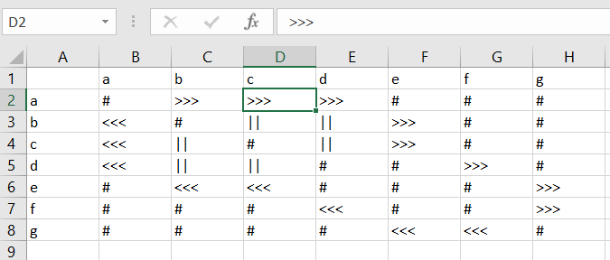

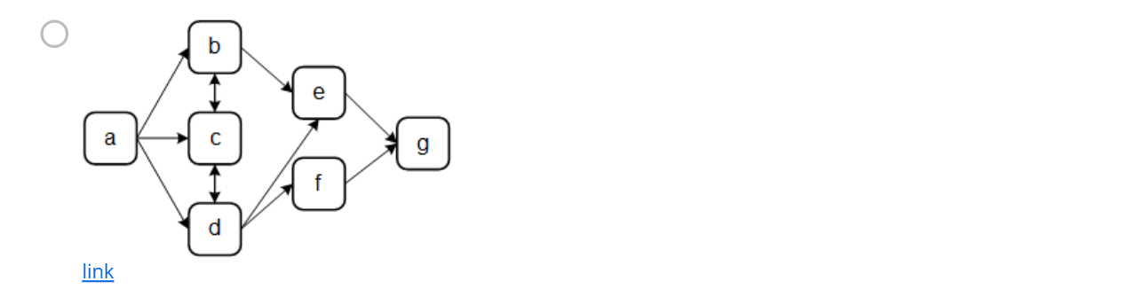

This option is neglected because there is parallel dependency

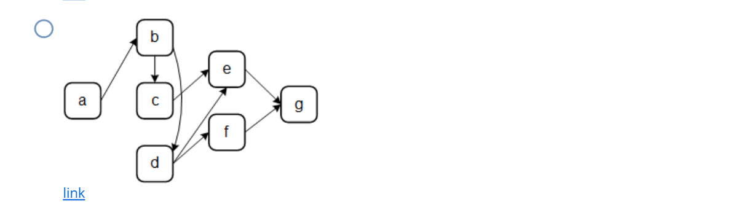

This option is neglected because a >>> c is not there

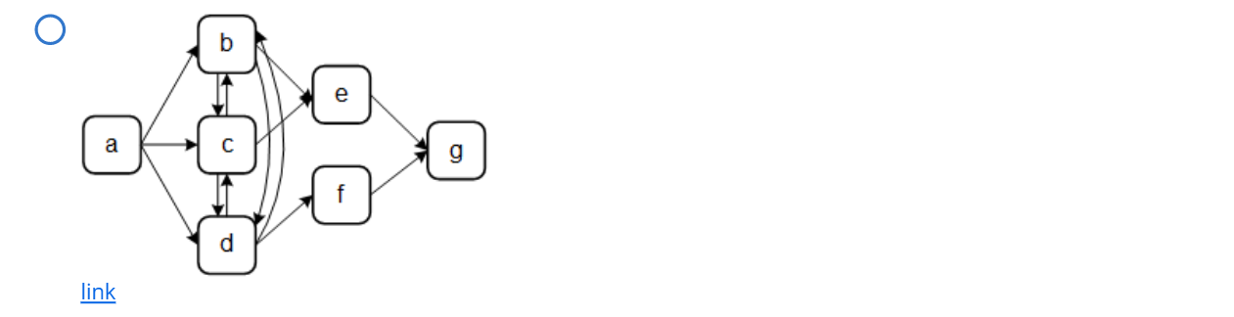

This option is neglected because of parallel dependency

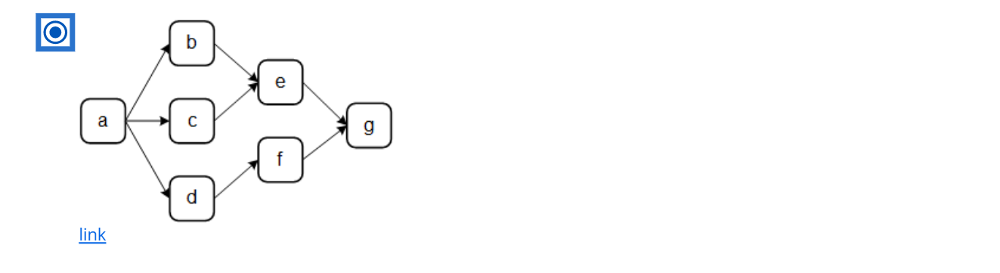

This is the right option as it follows all the dependencies correctly

Question 9 :

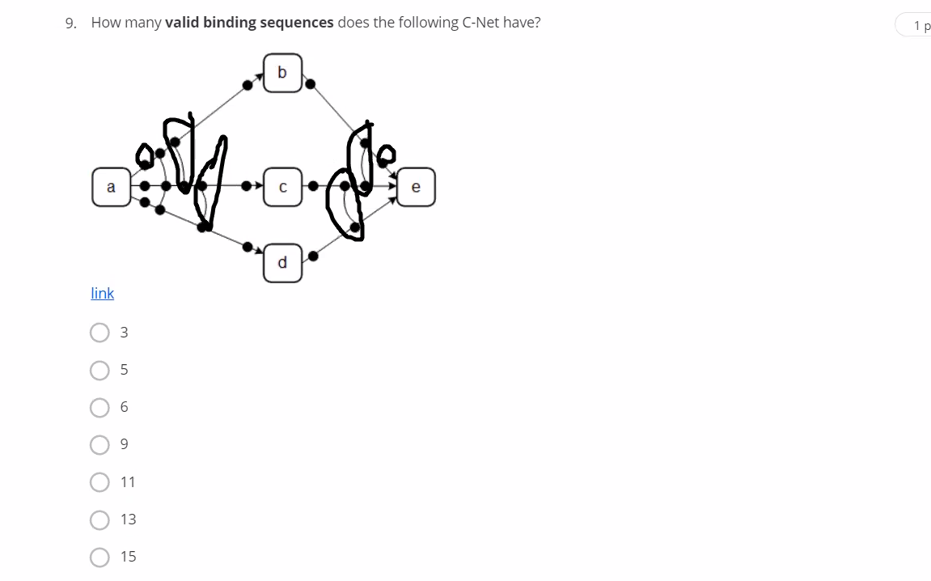

Bindings which are present in left should be present in right

One single binding and 2 double bindings. So totally 5

Question 10:

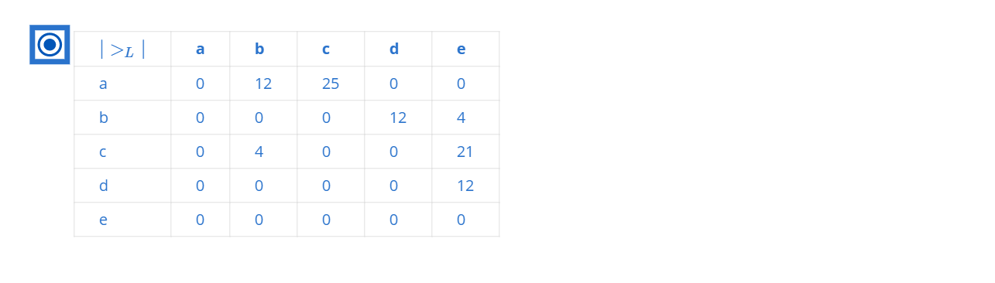

This matrix supports values if the two variables are near

Based on the given conditions check how much is ab, ac ,etx. If there are more than one time then add the results

Question 11:

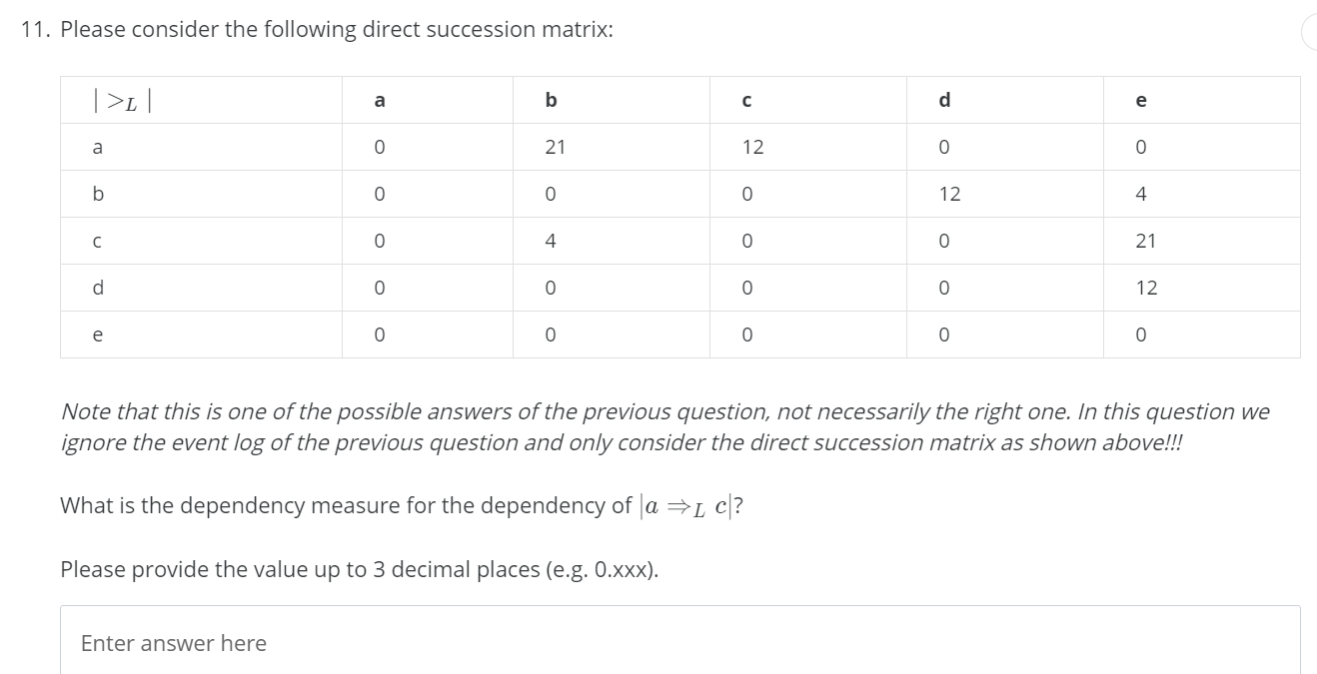

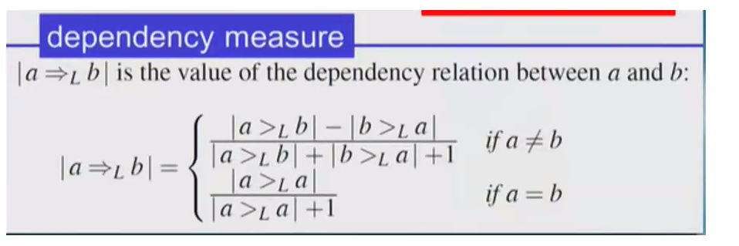

a =>Lc = (12-0)/12+1 = 12/13 = 0.923

Question 12:

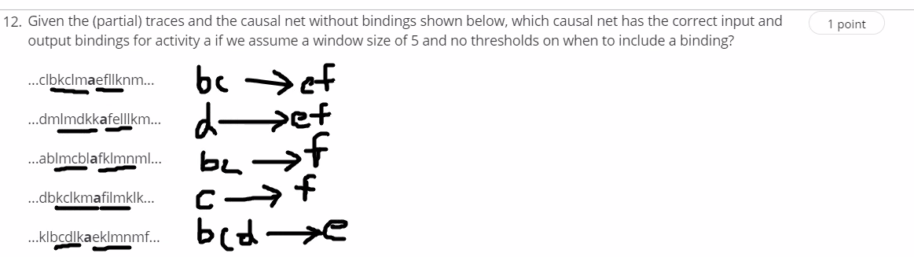

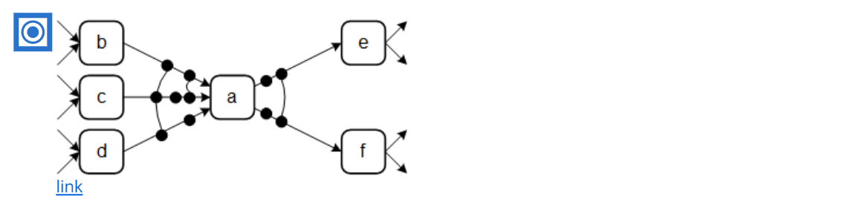

We got this answer based on the above picture

Question 13:

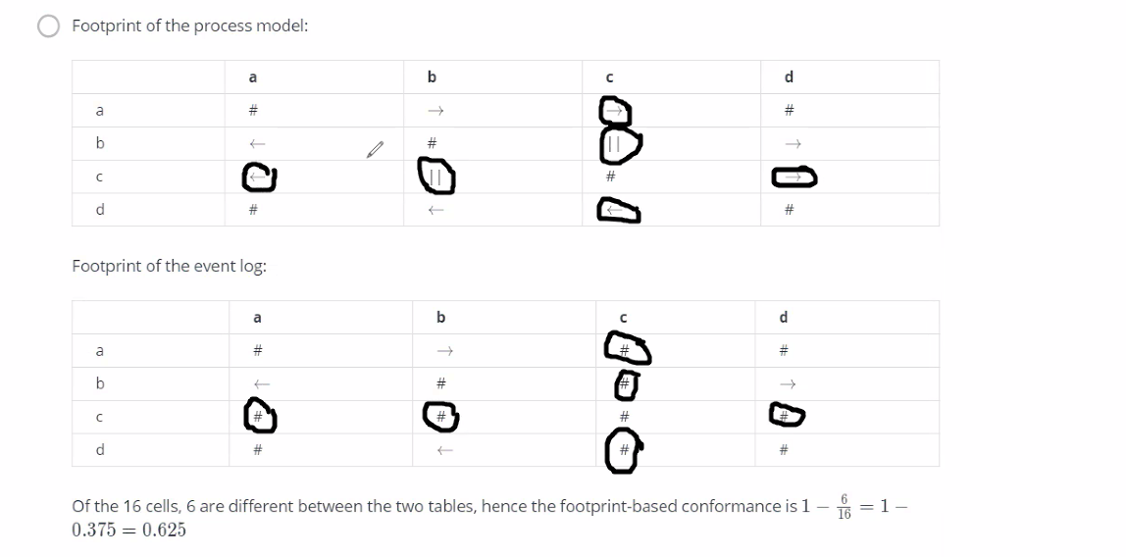

6 are mismatched out of 16. So 1 - 6/16 = 0.625

Question 14:

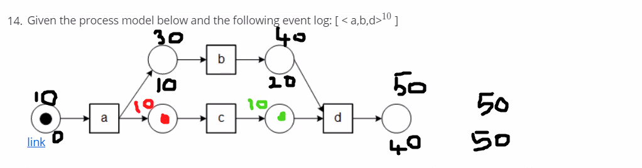

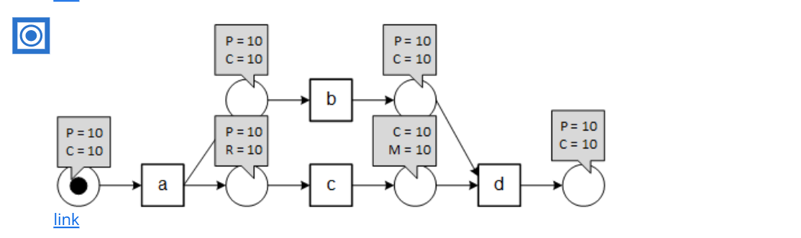

Question 15

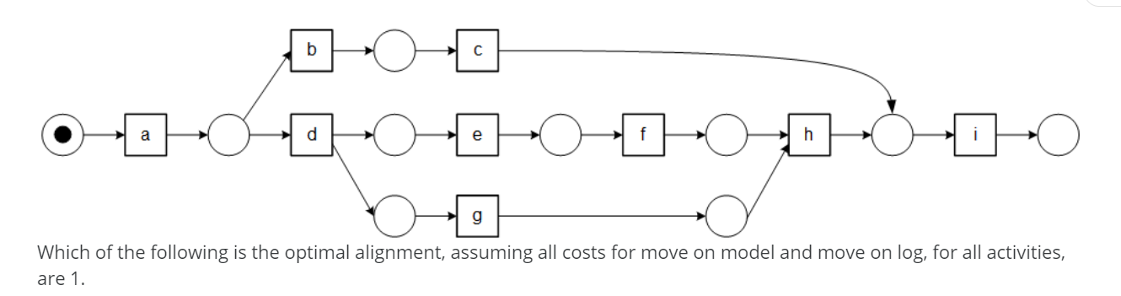

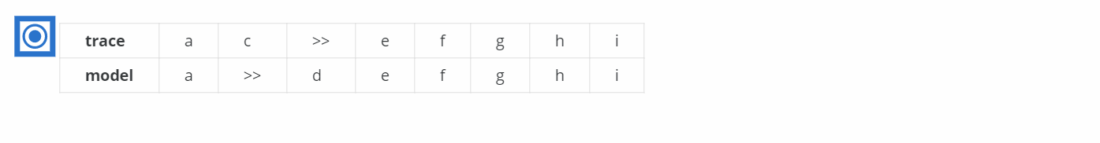

Trace is the event log

Whenever there is >> it means not possible

Eg: ac is possible in event log but not possible in the model

Similarly ad is possible in the model but not in the event log

Cost function is the number of >> present in trace and model.

For this the cost function is 2

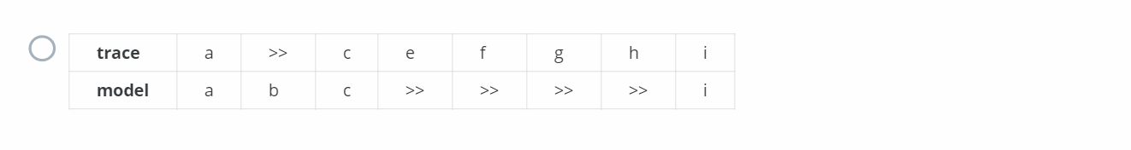

This option also satisfies all the criterion but the cost function is 5. Which is greater than 2, So this option is rejected

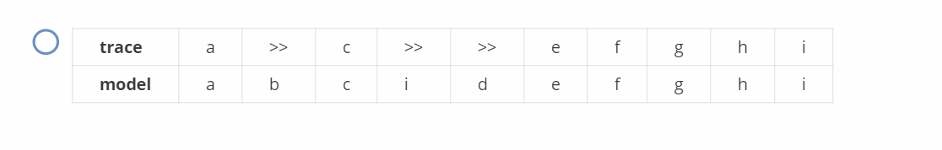

In this model from i he has jumped to d which is not possible. So the model itself is wrong. So it is rejected

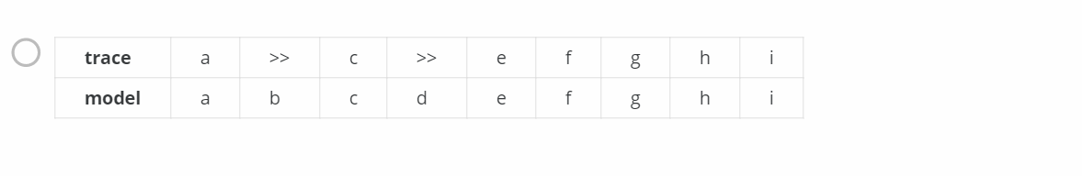

In this model after c he has jumped to d which is not possible. So it is rejected

First option is the most optimal solution

Question 16:

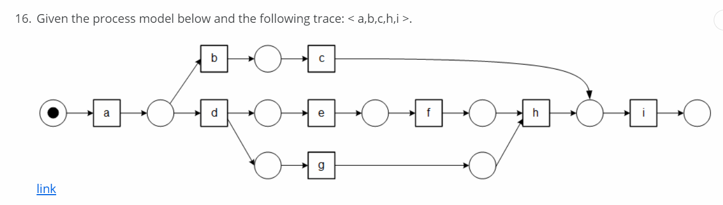

Conformance = 1 - (optimal alignment cost function/(event log size + shortest path in model))

Optimal alignment is



Because the cost function is 1



This is the worst alignment => event log size + shortest path in the model = 4 + 5 = 9

1 - (1/9) => 8/9 = 0.8889

Question 17:

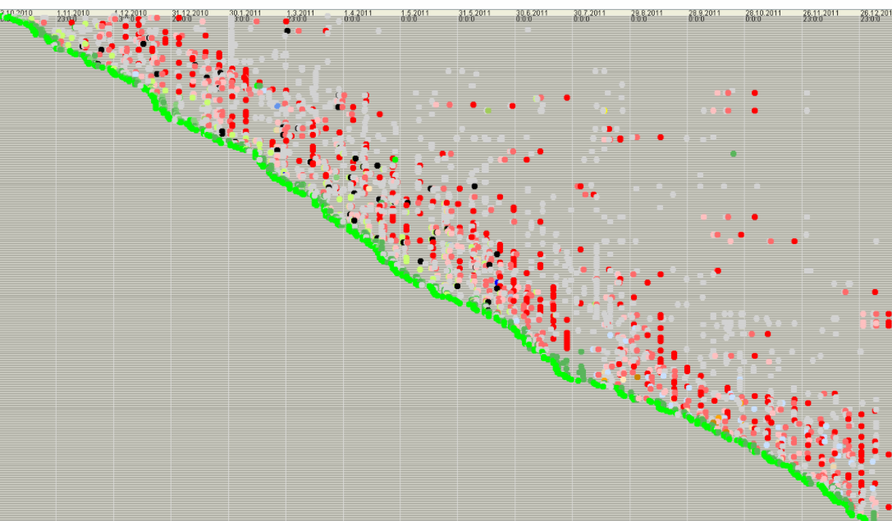

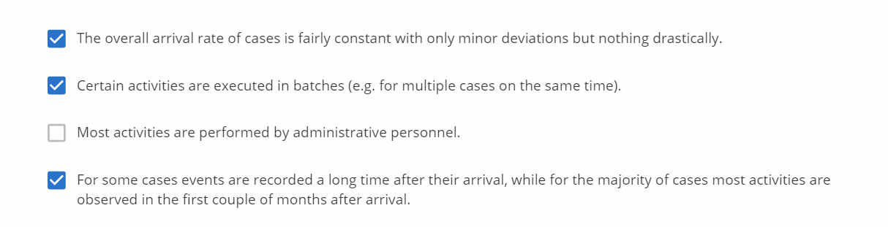

There is no special mention of administrative personnel. So this option is rejected

Question 18:

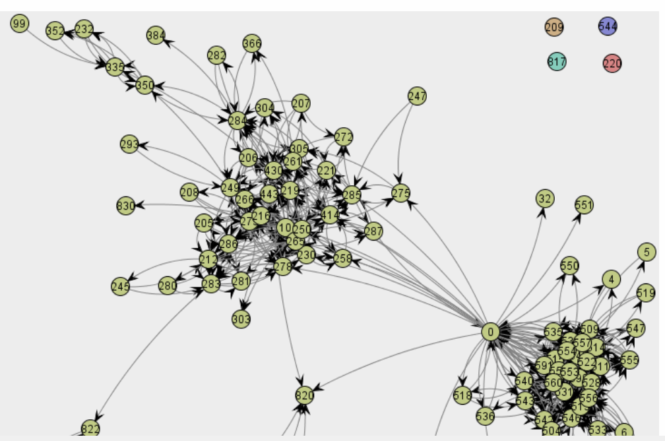

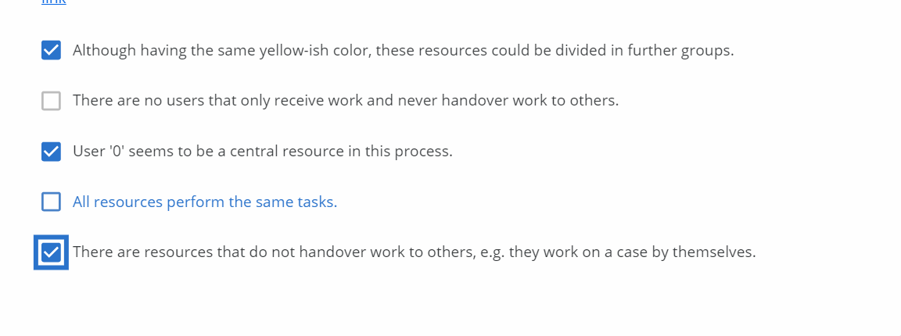

All resources do not perform the same tasks. Some users receive work an never handover it to others

Question 19:

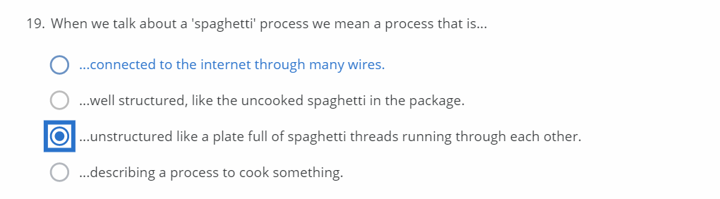

Question 20:

